Logging in

1. Follow the link from the specified scholarship scheme on <https://myscholarship-apply.gov.mt/>
2. Click on login at the upper right corner



1. Sign-in with your e-I.D login.

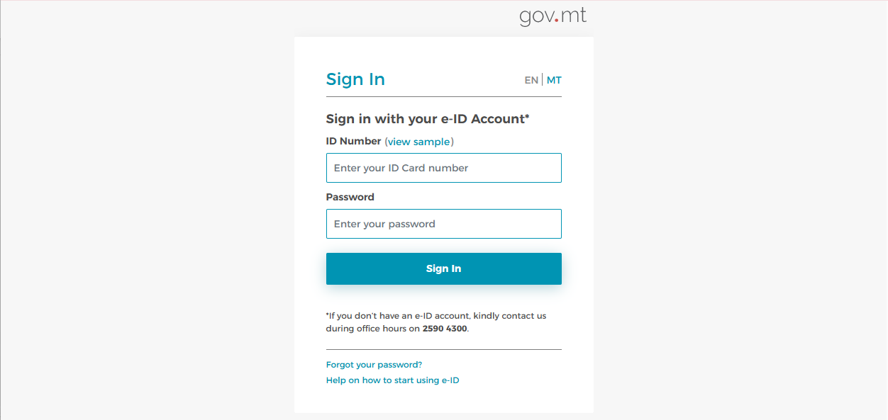

1. You will then receive a code via text message or through the authenticator app, which must be entered into the designated field shown circled below.

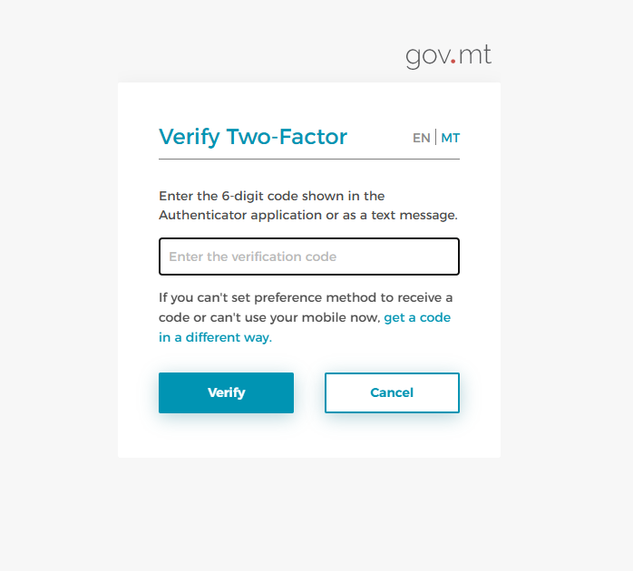

1. Click on ***“Continue”***.

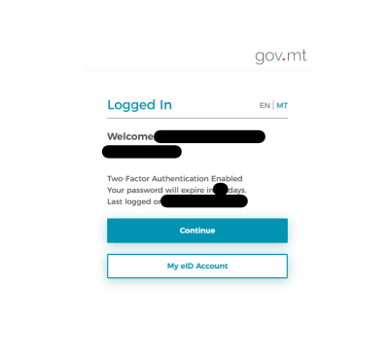

1. Click “***Proceed***” to continue.

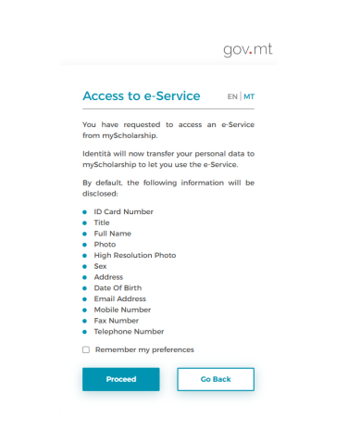

1. Go through all the tabs *Personal Details, Address, Qualifications* and *Employment* and fill as necessary. Do not forget to save. When you go through the last tab ‘*Employment*’ and save, you will be redirected on the Manage Profile as below. Click ‘*View Scholarships*’ to select your preferred scheme and continue as per instructions.

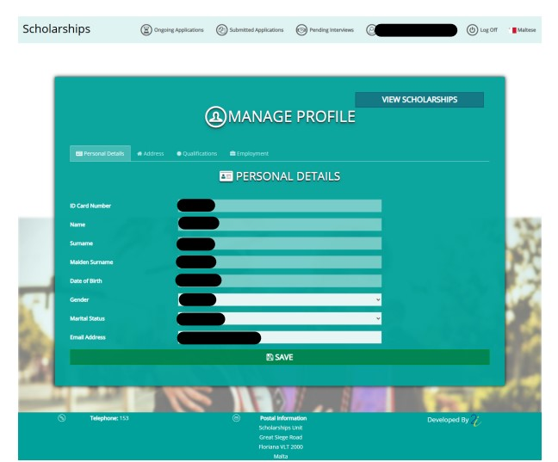

1. Choose your appropriate scheme and read the regulations. N.B. In the case of the ENDEAVOUR II Scholarships Scheme, **ONLY,** the application **will not** allow you to proceed if your MQF Level 7 or 8 course will commence before 9th May 2025. You must select another scheme which suits you best.

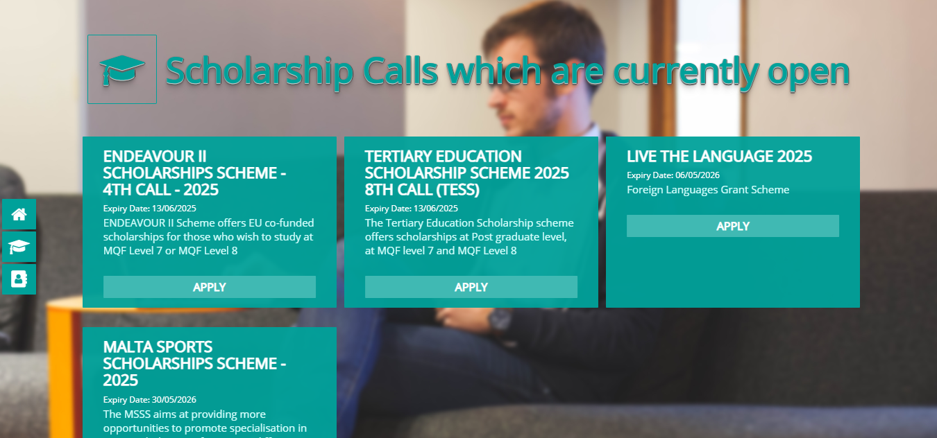

1. After reading the regulations and ticking the boxes below, press '***Apply***' to continue.

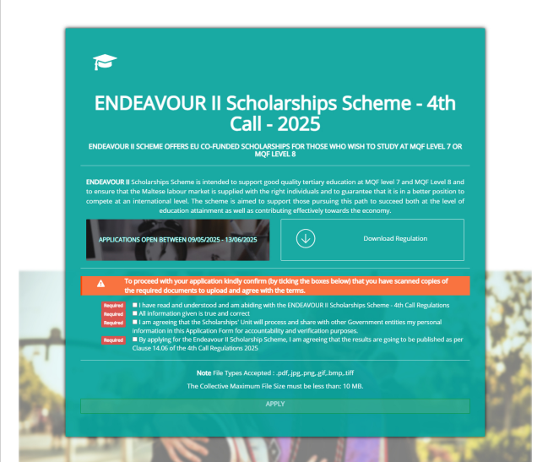

1. The website might ask you to log in with your e-ID again. If prompted, please do so; otherwise, you will be automatically redirected to your *‘Basic Details’* tab. Go through all the 8 tabs, tick the terms and conditions and when you submit, an automatic acknowledgement will be sent to your e-mail address provided in the Profile section.

